**Pre-requisites:**

* **AWS Account** with access to Amazon Redshift.
* Existing Redshift cluster using dc2.large instance type.
* Basic familiarity with the AWS Management Console.

**1. Backup Your Data (Optional but Recommended)**

Before resizing your cluster, it is a best practice to take a snapshot of your cluster to prevent data loss in case something goes wrong during the resize.

**Steps to Take a Snapshot:**

1. **Login to the AWS Management Console.**
2. Navigate to the **Amazon Redshift Console**.
3. In the left-hand pane, select **Clusters**

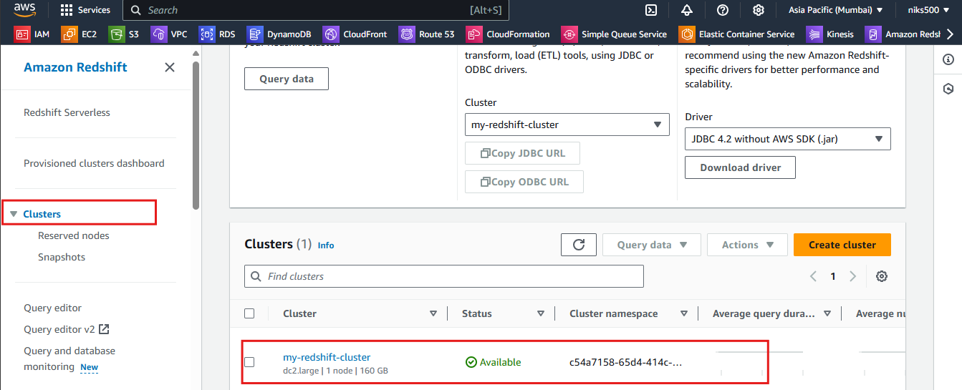

1. Click on your cluster that you want to resize (it should be using dc2.large nodes).
2. Under the **Actions** dropdown menu, select **Take Snapshot**.

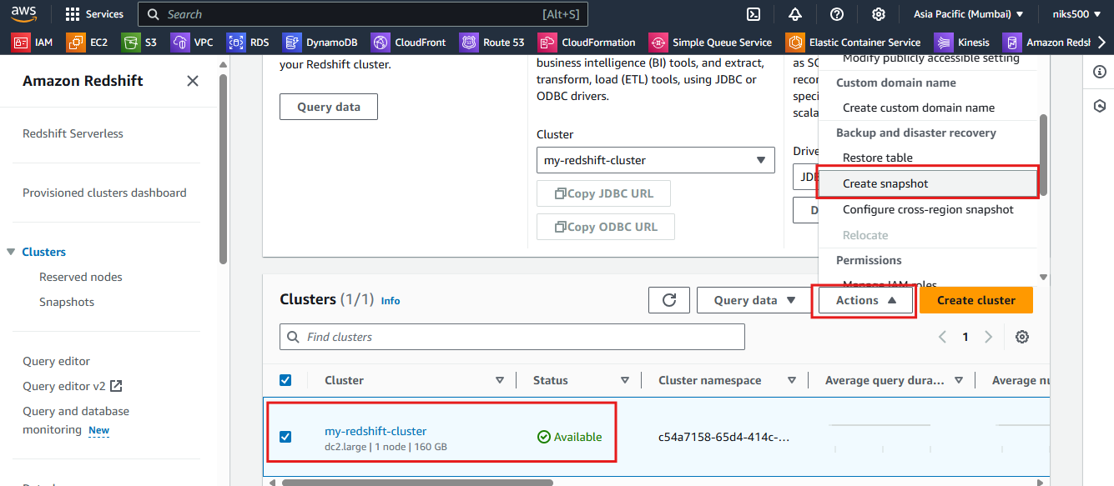

1. Name the snapshot (optional) and click **Take Snapshot**.

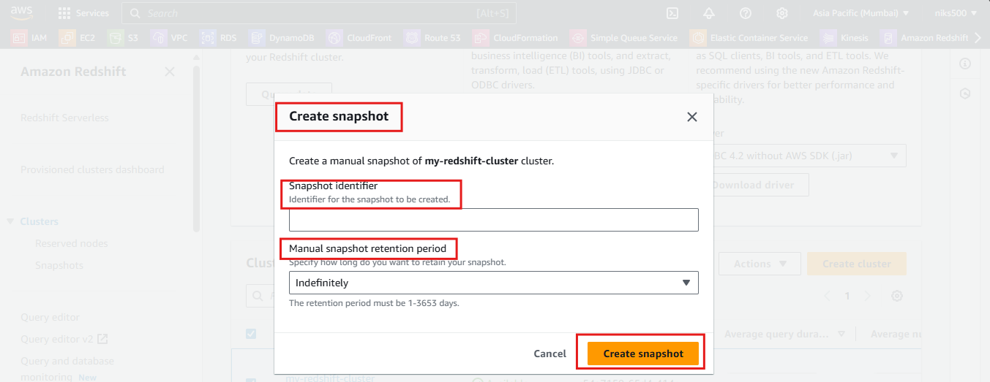

1. Wait for the snapshot process to complete. You can monitor the status under the **Snapshots** section in the Amazon Redshift console.

**2. Resize the Cluster**

1. **Start the Resize Process**:
   * Go to **Clusters** in the left-hand navigation pane.
   * Select your **dc2.large** cluster that you want to resize.
   * Click on the **Actions** button on the top-right of the page and select **Resize Cluster**.

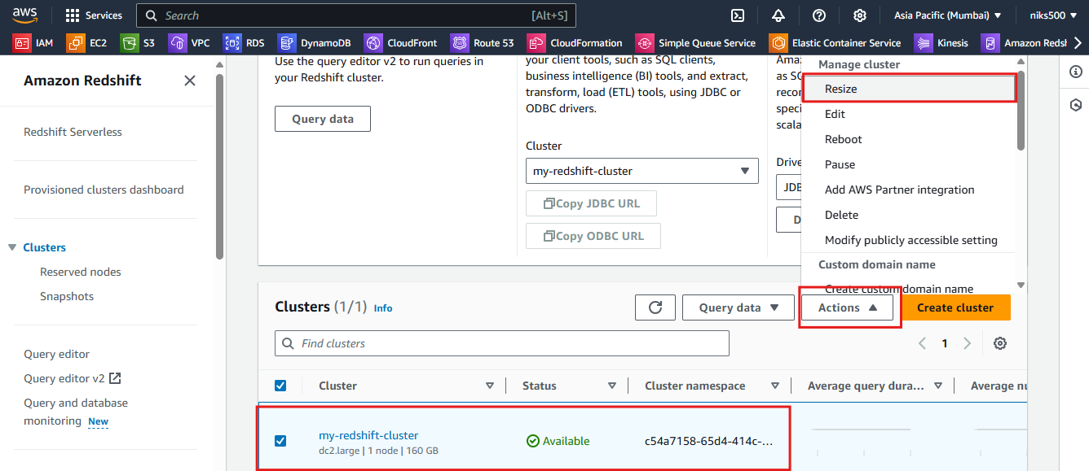

1. **Select Resize Type**:
   * You will be prompted with two resizing options:
     + **Elastic Resize**: For small changes (e.g., adding/removing nodes). This is not ideal for changing the instance type.
     + **Classic Resize**: This is the option to change the node type. Select **Classic Resize** for changing from dc2.large to ra3.xlplus.

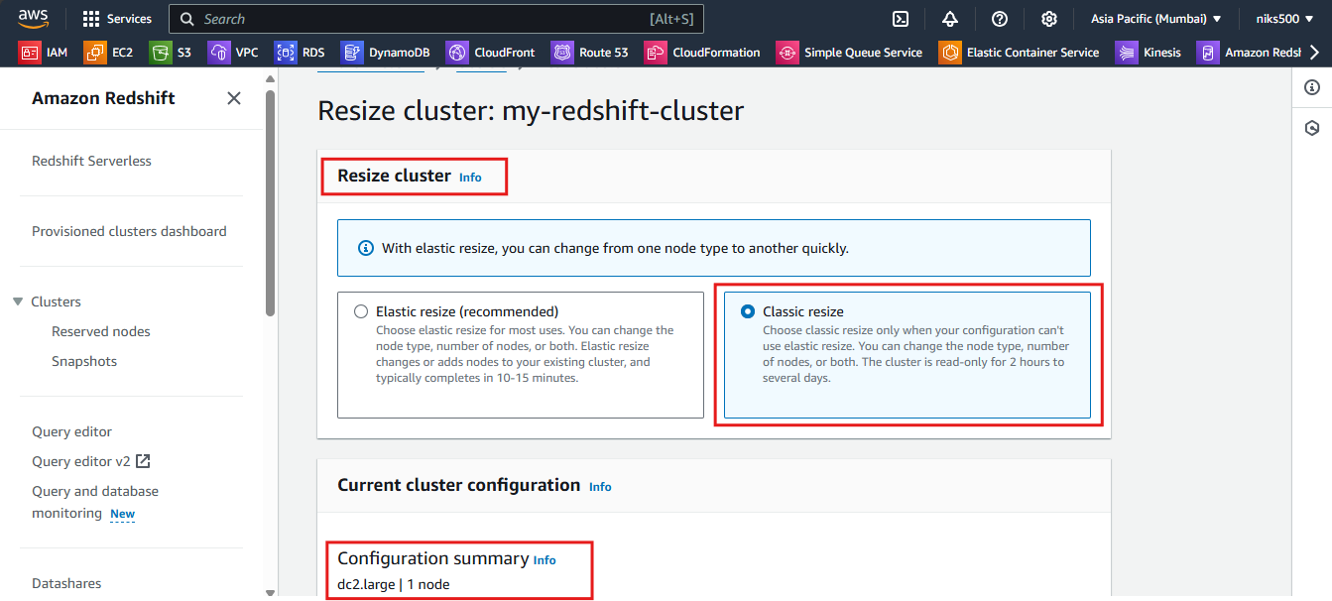

1. **Specify the New Node Type**:
   * **Node Type**: From the dropdown, select ra3.xlplus.
   * **Number of Nodes**: Choose the number of nodes for your new cluster. You can scale up or down as needed based on your workload (e.g., 2 or 3 nodes).

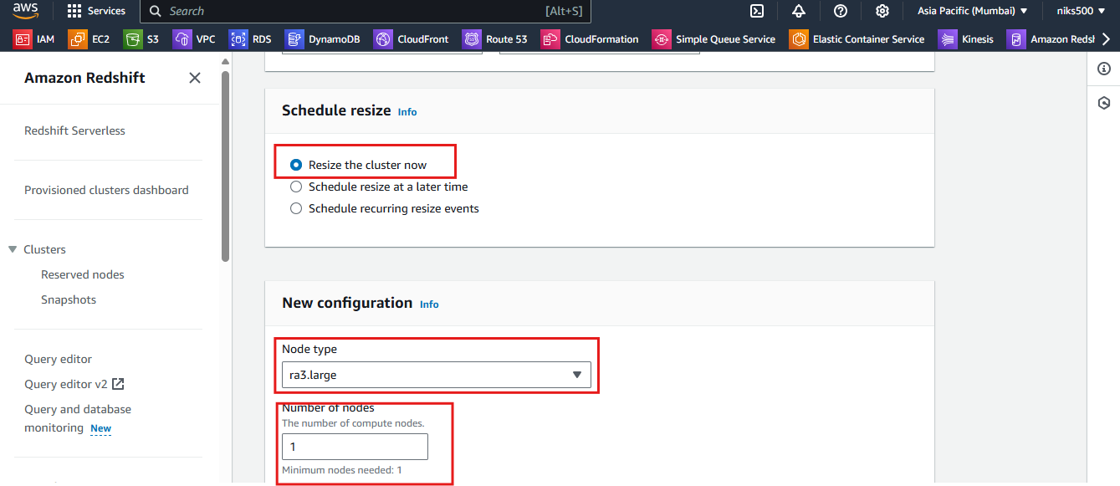

1. **Other Configuration**:
   * Ensure that all the other settings (like VPC, security groups, etc.) are correct. These should remain unchanged unless you want to modify them during the resize process.
2. **Start the Resize**:
   * Once you've selected the appropriate configurations, click **Resize Cluster** to initiate the process.

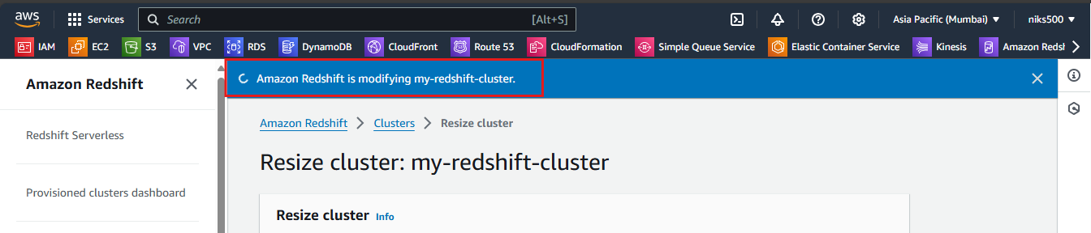

**Important**: The resizing process will cause downtime. The cluster will be unavailable while the resize operation is in progress.



